Module 9

Assignment 9.2
Course: CSD420-340A Advanced Java for Programmers
Prepared By: Mirach Erkol
Date of Report: 5/10/2026

https://github.com/Mikey5007/csd-420.git

9.2 Assignment: Compiling and Running Java Files
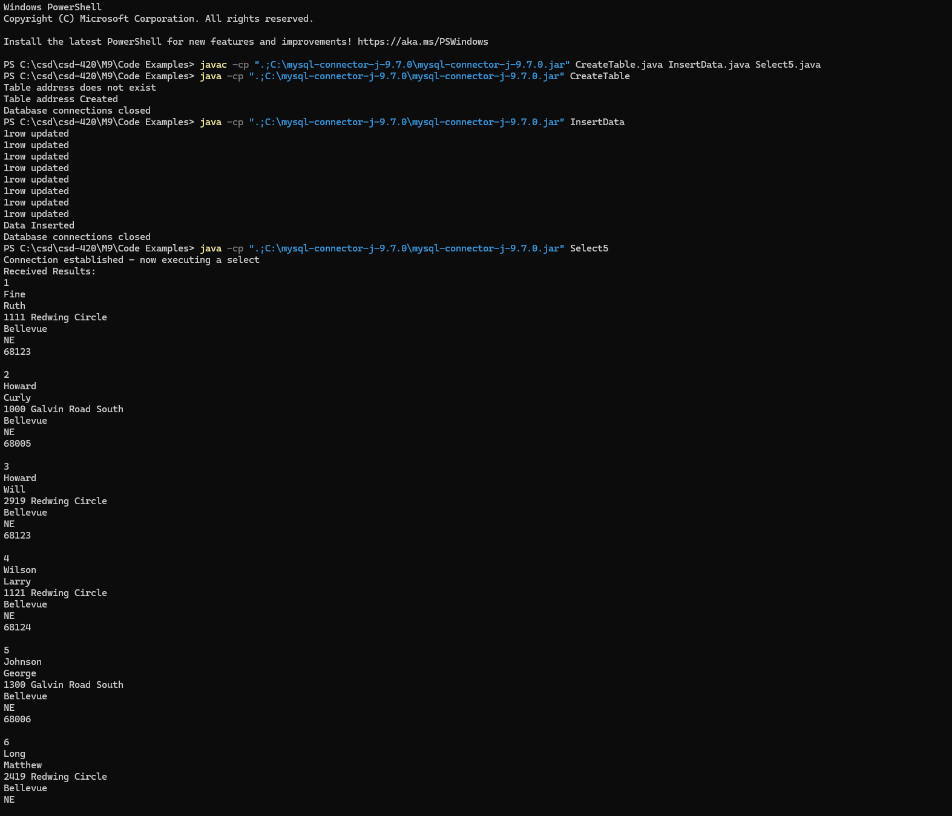

9.2 Assignment: Database Creation
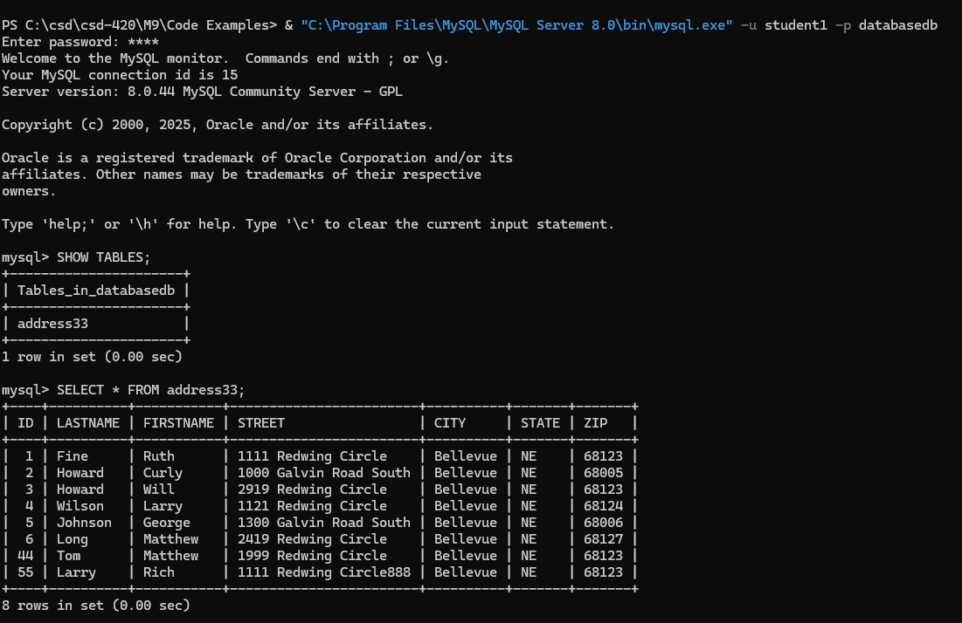

9.2 Assignment: Application Installation and Configurations

Java
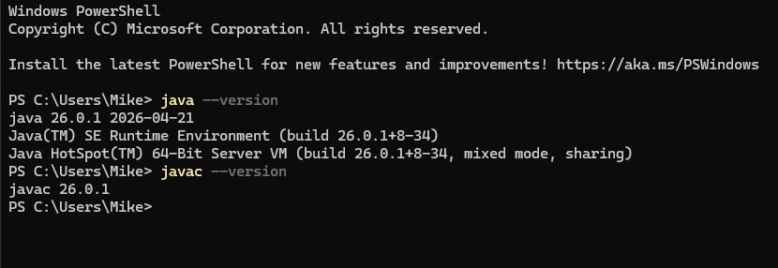

NetBeans
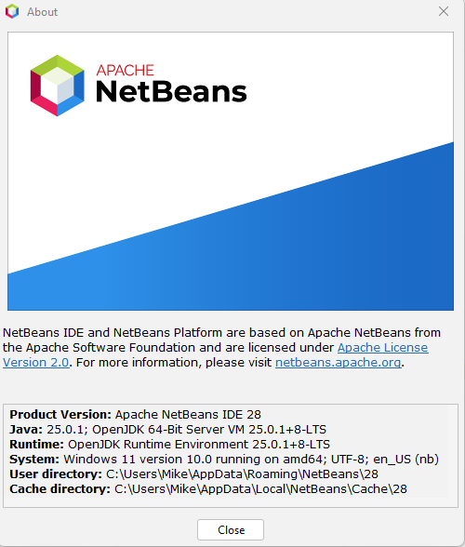

References:

https://github.com/Mikey5007/csd-420.git

